Epsom & Ewell F.C.
9
v
Godalming Town
Tuesday, 21st November 2017 – 7.45 p.m.
Good evening and welcome to High Road for our important League match against Godalming Town. We welcome their players, supporters and officials and wish them a safe journey home, as of course we do for our own regular faces.

When considering that both clubs are Surrey based, it is a surprise how rarely we have met. We used to play a forerunner of theirs back in the Twenties, but we have only met the current club once, and even then it was under their former name of Godalming & Guildford, when we edged them out of the Surrey Senior Cup 2-1 at Merland Rise in November of 2004 with goals from Charlie Pritchard and Richard Ingham. The winning goal was I recall, very late in the match.

To say that this match is far more important than that last meeting is a bit of an understatement! If you had asked most people at the start of August, they might have assumed that this would be a tough battle between a pair of clubs looking for promotion, yet both have suffered horrible seasons to this point and have found themselves cut adrift at the bottom of the table. We have no idea yet how many teams will be relegated at the end of the season, but if either of us are to get out of trouble, three points tonight is paramount as we know that at least one must go.

We were last here seven days ago when we hosted Farnham Town and finally broke our League duck with a 3-0 win! The first half was fairly even but Liam Roberts provided two moments of quality that put us ahead and Lloyd Connelly finished off from a clever flick by Taryn Smith. By the end they were a well beaten side. Following that, on Saturday we visited A.F.C. Hayes for another pivotal fixture and were desperately unlucky to go down to two late goals in a 2-0 defeat. We were the better team but didn’t take the chances on a miserable afternoon for football.

This coming Saturday we meet Balham F.C. for the first time. They currently share at Colliers Wood United, so you all know the way! After that we have a difficult looking Surrey Senior Cup tie at Sutton Common Rovers on the Monday evening before we return here on Saturday 2nd December for the visit of Guildford City.

Thank you to those who have stepped forward to sponsor either a match or player, or in some cases, both! The sponsorship (£60) includes free entry for three people, including programmes and hospitality and in a new initiative you get to choose the player of the match, which will result in a prize for that player. The players are available to sponsor at £40 a time, so please help our club by letting a Committee member know. The latest list of players is available in today’s programme. Finally, we are also taking orders for our new Centenary merchandise shortly, which is pictured at the back of the programme. Please help us by ordering a shirt or two!

Enjoy the game.

Rich
Don’t forget, you can now follow us on Social Media. Please see the inside cover for addresses.

Cover photos by Gemma Jarman

- Liam Roberts puts us ahead against Farnham Town with a curling strike last Tuesday

- Liam also scores our second goal in the same match

Cherry Red Records Combined Counties League
Premier Division Table 2017/18
inc Saturday 18th Nov | P | W | D | L | F | A | Pts | GD | H | A
Westfield | 17 | 15 | 1 | 1 | 63 | 18 | 46 | +45 | 14/4 | 9/12
Walton & Hersham | 18 | 12 | 3 | 3 | 45 | 18 | 39 | +27 | 30/12 | 21/4
Bedfont Sports | 17 | 11 | 3 | 3 | 48 | 23 | 36 | +25 | 24/3 | 0-7
Sutton Common Rovers | 17 | 10 | 3 | 4 | 34 | 22 | 33 | +12 | 3/2 | 0-5
Hanworth Villa | 17 | 8 | 6 | 3 | 35 | 28 | 30 | +7 | 1-1 | 10/2
Camberley Town | 18 | 7 | 8 | 3 | 25 | 21 | 29 | +4 | 10/3 | 1-1
Knaphill | 18 | 8 | 4 | 6 | 39 | 37 | 28 | +2 | 24/2 | 2-6
Horley Town | 17 | 9 | 1 | 7 | 28 | 35 | 28 | -7 | 2-3 | 23/12
Balham | 16 | 7 | 4 | 5 | 32 | 27 | 25 | +5 | 20/1 | 25/11
Spelthorne Sports | 19 | 7 | 4 | 8 | 36 | 33 | 25 | +3 | 1-5 | 27/1
Guildford City | 17 | 7 | 2 | 8 | 27 | 32 | 23 | -5 | 2/12 | 7/4
North Greenford United | 17 | 5 | 7 | 5 | 29 | 28 | 22 | +1 | 1-2 | 17/3
CB Hounslow United | 16 | 6 | 3 | 7 | 23 | 21 | 21 | +2 | 13/2 | 2-4
Abbey Rangers | 17 | 6 | 3 | 8 | 26 | 27 | 21 | -1 | 16/12 | 17/2
Farnham Town | 16 | 5 | 4 | 7 | 24 | 32 | 19 | -8 | 3-0 | 0-0
Redhill | 17 | 5 | 3 | 9 | 28 | 31 | 18 | -3 | 0-5 | 6/1
Colliers Wood United | 18 | 5 | 2 | 11 | 32 | 36 | 17 | -4 | 30/3 | 2-5
AFC Hayes | 15 | 5 | 2 | 8 | 20 | 26 | 17 | -6 | 28/4 | 0-2
Banstead Athletic | 16 | 4 | 5 | 7 | 22 | 35 | 17 | -13 | 2/4 | 1-1
Chertsey Town | 19 | 5 | 2 | 12 | 27 | 47 | 17 | -20 | 2-7 | 0-1
Godalming Town | 17 | 1 | 4 | 12 | 17 | 46 | 7 | -29 | 21/11 | 13/1
Epsom and Ewell | 17 | 1 | 4 | 12 | 18 | 55 | 7 | -37 | X | X
1

Lucky Day? – 21st November
Played 15 - Won 6 Drawn 3 Lost 6 - For 29 Against 24 - PPG 1.40 - Average
Our Club record against Godalming Town
Played 1 - Won 1 Drawn 0 Lost 0 - For 2 Against 1 - PPG 3.00 - Perfect
Our Club record against the old Godalming F.C.
Played 9 - Won 8 Drawn 1 Lost 0 - For 37 Against 8 - PPG 2.75 - Fantastic
Their Last Visit
2nd November 2004 - Won 2-1 - Surrey Senior Cup

First Eleven Appearances 2017/18 - (max 21)
Name | Debut | 2016/17 |  |  |  | Career Totals
 |  | App | Sub | Total | Goals | App | Sub | Total | Goals
AJAYI Tayo | 06/08/2017 | 3 | 4 | 7 | 1 | 3 | 4 | 7 | 1
BROOKS Jordan* | 06/08/2017 | 3 | 0 | 3 | 0 | 3 | 0 | 3 | 0
CASTELL Cristian* | 06/08/2017 | 2 | 4 | 6 | 0 | 2 | 4 | 6 | 0
CONNELLY Lloyd | 14/10/2017 | 8 | 0 | 8 | 2 | 8 | 0 | 8 | 2
DEWAR Ali | 29/10/2011 | 1 | 2 | 3 | 0 | 56 | 42 | 98 | 10
DOBRAJ Endrit | 18/11/2017 | 0 | 1 | 1 | 0 | 0 | 1 | 1 | 0
DYSON Ben | 12/08/2017 | 15 | 1 | 16 | 1 | 15 | 1 | 16 | 1
FRANKLIN Ben | 03/03/2015 | 1 | 1 | 2 | 0 | 2 | 1 | 3 | 0
GRAHAM Bentley | 09/02/2016 | 3 | 0 | 3 | 0 | 20 | 1 | 21 | 3
GRANDISON Kane | 11/11/2017 | 3 | 0 | 3 | 0 | 3 | 0 | 3 | 0
GRIFFIN Reisse | 08/08/2015 | 15 | 0 | 15 | 1 | 88 | 13 | 101 | 7
HARLAND-GODDARD Tom* | 06/08/2017 | 1 | 1 | 2 | 0 | 1 | 1 | 2 | 0
HARRIS Colin | 04/08/2012 | 9 | 0 | 9 | 0 | 34 | 0 | 34 | 0
HATFIELD Jamie | 11/11/2006 | 9 | 1 | 10 | 0 | 258 | 14 | 272 | 6
HAYWARD Ben | 07/03/2007 | 5 | 1 | 6 | 0 | 248 | 29 | 277 | 18
HEAGNEY Adam | 16/08/2016 | 8 | 1 | 9 | 0 | 45 | 10 | 55 | 1
HENDRY Rob | 08/08/2015 | 12 | 0 | 12 | 4 | 80 | 22 | 102 | 27
HOUGH Kyle | 14/08/2007 | 10 | 2 | 12 | 6 | 343 | 21 | 364 | 207
JASPER Joe | 11/11/2017 | 0 | 1 | 1 | 0 | 0 | 1 | 1 | 0
KENNEDY Calum | 18/11/2017 | 0 | 1 | 1 | 0 | 0 | 1 | 1 | 0
LAW Franky* | 06/08/2017 | 3 | 0 | 3 | 0 | 3 | 0 | 3 | 0
LOFTUS-CHEEK Joe | 06/08/2017 | 9 | 2 | 11 | 2 | 9 | 2 | 11 | 2
MARVELL Dale | 15/01/2000 | 16 | 2 | 18 | 0 | 285 | 51 | 336 | 86
MCKAY Alex | 20/12/2008 | 8 | 1 | 9 | 1 | 139 | 38 | 177 | 13
MURPHY George | 19/03/2013 | 2 | 0 | 2 | 0 | 70 | 7 | 77 | 3
MURPHY Scott | 20/01/2007 | 11 | 0 | 11 | 0 | 23 | 2 | 25 | 1
MYERS Antony | 23/12/2006 | 1 | 0 | 1 | 0 | 76 | 33 | 109 | 9
NWACHUKWU Jason | 01/10/2016 | 9 | 4 | 13 | 2 | 26 | 20 | 46 | 3
O'BRIEN Louis* | 28/08/2017 | 1 | 3 | 4 | 0 | 1 | 3 | 4 | 0
ROBERTS Liam | 12/08/2017 | 9 | 6 | 15 | 4 | 9 | 6 | 15 | 4
ROBINSON Sam* | 22/10/2011 | 5 | 0 | 5 | 0 | 66 | 6 | 72 | 14
ROSE Daniel | 25/10/2016 | 11 | 2 | 13 | 1 | 13 | 7 | 20 | 1
SMITH Andy* | 25/08/2017 | 2 | 0 | 2 | 0 | 2 | 0 | 2 | 0
SMITH Taryn | 28/10/2017 | 4 | 1 | 5 | 0 | 4 | 1 | 5 | 0
THOMPSON Ashley | 21/08/2017 | 14 | 1 | 15 | 3 | 14 | 1 | 15 | 3
THOMSON David* | 02/09/2017 | 2 | 2 | 4 | 0 | 2 | 2 | 4 | 0
WHITE Sean | 02/08/2014 | 6 | 7 | 13 | 2 | 12 | 20 | 32 | 5
YOUNG Conor | 07/03/2015 | 10 | 0 | 10 | 0 | 11 | 0 | 11 | 0
* Player has left the club

Results and Fixtures so far
Combined Counties League – Monday 13th November
Sutton Common Rovers | 3-1 | Spelthorne Sports
Surrey Senior Cup – Tuesday 14th November
Dorking Wanderers | 4-1 | Godalming Town
Combined Counties League Cup – Tuesday 14th November
Bedfont Sports | 0-1 | Walton & Hersham
North Greenford United | 0-4 | Colliers Wood United
Combined Counties League – Tuesday 14th November
Epsom & Ewell | 3-0 | Farnham Town
Knaphill | 4-0 | Horley Town
Westfield | 2-1 | CB Hounslow United
Combined Counties League – Wednesday 15th November
Guildford City | 0-6 | Balham
Combined Counties League – Saturday 18th November
Abbey Rangers | 4-2 | Colliers Wood United
AFC Hayes | 2-0 | Epsom & Ewell
Balham | 1-2 | Westfield
Banstead Athletic | 1-1 | Knaphill
Camberley Town | 0-0 | North Greenford United
Farnham Town | 1-2 | CB Hounslow United
Godalming Town | 0-4 | Bedfont Sports
Hanworth Villa | 2-1 | Sutton Common Rovers
Horley Town | 2-0 | Chertsey Town
Redhill | 0-3 | Walton & Hersham
Spelthorne Sports | 3-3 | Guildford City
Combined Counties League Cup – Tuesday 21st November
Knaphill | V | Kensington Borough
Combined Counties League – Tuesday 21st November
Epsom & Ewell | V | Godalming Town
Westfield | V | Hanworth Villa
Combined Counties League – Wednesday 22nd November
Guildford City | V | Banstead Athletic
Sutton Common Rovers | V | Horley Town
Combined Counties League – Saturday 25th November
Balham | V | Epsom & Ewell
Banstead Athletic | V | Camberley Town
Bedfont Sports | V | Hanworth Villa
CB Hounslow United | V | Spelthorne Sports
Chertsey Town | V | Colliers Wood United
Guildford City | V | AFC Hayes
Horley Town | V | Godalming Town
Knaphill | V | Abbey Rangers
North Greenford United | V | Farnham Town
Sutton Common Rovers | V | Walton & Hersham
Results and Fixtures so far
Combined Counties League – Saturday 25th November
Westfield | V | Redhill
Combined Counties League Cup – Tuesday 28th November
Spelthorne Sports | V | Chertsey Town
Combined Counties League – Tuesday 28th November
Farnham Town | V | Bedfont Sports
Combined Counties League – Wednesday 29th November
Colliers Wood United | V | CB Hounslow United
Combined Counties League – Saturday 2nd December
Abbey Rangers | V | Banstead Athletic
AFC Hayes | V | Camberley Town
CB Hounslow United | V | Balham
Epsom & Ewell | V | Guildford City
Farnham Town | V | Sutton Common Rovers
Godalming Town | V | Redhill
Hanworth Villa | V | Chertsey Town
Spelthorne Sports | V | North Greenford United
Buildbase F.A. Vase Third Round – Saturday 2nd December
Crowborough Athletic | V | Westfield
Horley Town | V | Baffins Milton Rovers
Walton & Hersham | V | Windsor

Surrey Senior Cup
Preliminary Round
Westfield | 3-2 | Abbey Rangers
Dorking Wanderers | 4-1 | Walton Casuals
Knaphill | 1-2 | Met Police
First Round
Westfield | 28/11 | Camberley Town
Woking | 5/12 | Chipstead
Chertsey Town | 21/11 | Spelthorne Sports
Dorking Wanderers | 4-1 | Godalming Town
Horley Town | 5/12 | Kingstonian
AFC Croydon Athletic | 28/11 | Met Police
Tooting & Mitcham United | 29/11 | Corinthian Casuals
Carshalton Athletic | 20/11 | Egham Town
Croydon | 2-2 - 11-12p | Molesey
Farnham Town | 21/11 | Whyteleafe
Sutton United | 28/11 | Redhill
Banstead Athletic | 30/11 | Leatherhead
Sutton Common Rovers | 27/11 | Epsom & Ewell
Guildford City | 2-2 - 3-5p | Colliers Wood United
Merstham | 21/11 | Walton & Hersham
South Park | 2-2 – 4-2p | Ashford Town (Mx)

From behind the goal
Epsom & Ewell 3-0 Farnham Town
Combined Counties League - Premier Division - Tuesday 14th November 2017

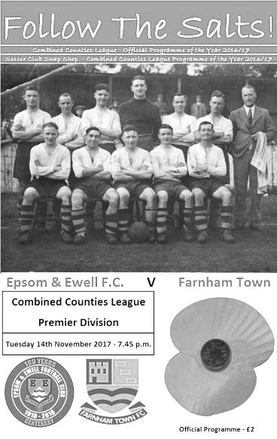
Salts finally break their League duck

At the sixteenth attempt, we finally managed to win our first League match of the season as we finished comfortable 3-0 winners over Farnham Town, who had come into the match on a twelve match unbeaten League run. It was all the more impressive when considering how much work had been put in over 120 minutes just three days previously at Whitstable Town and placed us level at the bottom with Godalming Town who we face shortly.

Of course Farnham had also suffered a narrow Vase defeat at the weekend but of the two teams, clearly we responded best to that defeat and to register a clean sheet into the bargain was an extra bonus. It is interesting to note that we have just two clean sheets this season and both have come against Farnham Town, following our goalless draw there in September.

In terms of personnel, both Dan Rose and George Murphy were given the night off while Reisse Griffin and Taryn Smith came in for them and the opening exchanges gave the impression that this would be an open match. The visitors struck a 25 yard effort which deflected away for a corner and from a deep delivery a strike at the far post was kept out by Conor Young, but within seconds we were attacking at the other end with Liam Roberts putting in a good run, although he dragged his shot wide from twenty yards.

The contest continued to be quite end to end and Lloyd Connelly set up Taryn Smith with a clever back heel but his shot on goal was blocked for a corner by keeper Adrian Giles with Roberts waiting in space. However, in the 10th minute Roberts would get his chance as Ashley Thompson put Ben Dyson through on the right hand channel and his ball across forced Roberts to cut back, but this left him a little wide. It didn't matter though as he cut inside and curled a twenty yard strike into the far corner of the net (see front cover of today’s programme).

Within a minute we had a bit of a scare as we didn't clear the ball and required Young to push the ball away from an oncoming striker while lying on the ground. Fortunately we were on the attack again soon after and extended our lead in the 16th minute. Lloyd Connelly laid a square ball into Roberts just outside the area and with one move his clever footwork took out two defenders and left him through on goal where he finished calmly from close range. It was a wonderful piece of skill and it has been quite some time that one player has scored two such special goals in one match.

Again though we were most vulnerable just after scoring and from where I was, Young appeared to take out a Farnham striker with a bit of a lunge. However, I am informed by those who were nearer the incident that no contact was actually made, and no penalty was given. The visitors were still well involved at this stage though and you knew that conceding at this point would have made for a long evening. What we needed was a third goal and Dyson so nearly provided it when he

latched on to a far post delivery, only to see his powerful strike rebound away from the foot of Giles' right hand post in the 25th minute.

Smith was unable to get a good contact on a Sean White cross in a good position while Roberts set him up shortly afterwards only to see his twenty-five yard drive deflected wide for a corner. In the 40th minute Roberts received a present from a poor defensive clearance and from twenty yards tried to chip Giles who just managed to get back to tip the ball over the bar. The half ended with Dale Marvell striking a free kick just wide of the bottom corner of the goal.

There have been times before where I wondered whether those missed chances would come back to haunt us but we were looking quite comfortable by this point and as long as we didn't concede early in the second half I thought we'd be ok. As it turned out we made it 3-0 shortly after the restart when with 51 minutes on the clock a flying back heel from Smith put Connelly through and he reached the ball ahead of Giles, leaving him with an easy finish!

Once again we nearly conceded straight after scoring as we tried to overplay in our own area and found their striker through on Young, but our keeper stood up well and deflected the shot wide from just ten yards out for a really good save. The next item of note was an excellent advantage by the referee as Smith got through on goal, but shot wide under pressure before James Flynn picked up a yellow card for his earlier foul.

Alex McKay got a header on target from a corner but although this didn't trouble Giles too much, the events in the 74th minute caused a great deal of panic in the Farnham goal as first Connelly headed a ball across the six yard area where Marvell couldn't quite reach it, but the danger wasn't cleared and Dyson produced a driving run before hitting a cross into the danger area, only to see the ball then rebound straight to him off a defender, but he probably wasn't expecting the ball back and rushed his shot at goal with Giles wrong footed only to see the ball came back off the post once again!

Still, with the score as it was, no one was going to lose much sleep over this with the possible exception of Dyson himself as we continued to push the Farnham team back more and more and in injury time McKay sent a deep cross back into the danger area where Joe Loftus-Cheek nearly scored with a back heel, but the ball was blocked on the line before being cleared.

The final whistle blew shortly afterwards and there was satisfaction of a job well done rather than wild celebration, as the players know that we still have a lot of work to do with key matches coming up against AFC Hayes and Godalming in the next seven days. Still it was nice to be able to reflect on our first complete ninety minutes performance and the first clean sheet for Young who had a great game and was also well protected by McKay, Marvell and making his one hundredth appearance Reisse Griffin, who was voted player of the match too. That might indicate that we did a lot of defending, but in truth there were superb performances across the field and this nucleus of players is beginning to take shape. Let's hope we can keep the momentum going.

Epsom and Ewell: Conor Young, Sean White, Liam Roberts, Dale Marvell,
Alex McKay (c), Reisse Griffin, Ben Dyson, Kane Grandison, Taryn Smith,
Lloyd Connelly, Ashley Thompson

Subs: Adam Heagney for Thompson (53), Ben Franklin for Roberts (61),
Joe Loftus-Cheek for Connelly (88)

Sponsors Player of the Match: Reisse Griffin

From behind the goal
AFC Hayes 2-0 Epsom & Ewell
Combined Counties League - Premier Division - Saturday 18th November 2017

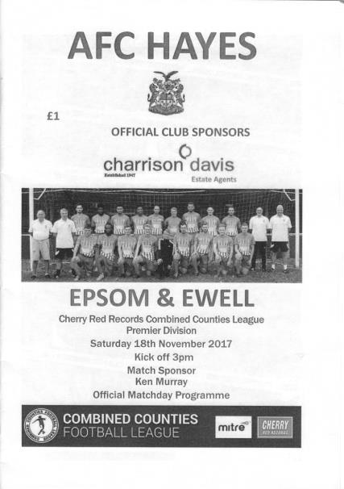
Salts made to pay for missed chances at Farm Park

On a very wet and miserable day in Middlesex, our boys did enough to win this important league match but missed chances, particularly in the first half, came back to haunt us as we then conceded two late goals to lose the point that would have taken us off the foot of the table.

The day started badly for supporters when it became apparent from the team news that our two goal hero from Tuesday's win over Farnham, Liam Roberts was unavailable due to work commitments. With other attacking options Kyle Hough and Rob Hendry still missing it was Taryn Smith and Lloyd Connelly who were given the unenviable task of putting the ball in the net on a pudding of a pitch and their jobs would be made tougher by having to use two substitutes in the first half due to injury, which led to both of our wing backs being moved or withdrawn from their roles.

We had a scare in the opening fifteen minutes when the home side lumped a long ball forward and their striker outran our defence and drilled a shot at Conor Young which he was able to block with his feet. However, this run caused a recurrence of a hamstring injury for George Murphy and he was replaced by Sean White with Reisse Griffin dropping back into Murphy's role in central defence. This was a real pity as he had already made inroads down the right on a few occasions.

Maybe the first indication that it wasn't going to be our day came when a poor defensive clearance left Connelly in a good position and he got a powerful shot away from inside the penalty area, only to see it deflected just wide of Cameron Kennedy's right hand post for a corner. Although that corner came to nothing, the next one we won was retrieved at the far post by Alex McKay who crossed the ball in to Dale Marvell, but his header was cleared off the line by a defender.

We were well on top at this point and 21 minutes in Connelly found Smith with a good header but as he rounded the Kennedy he went a little wide and his attempt on goal was also cleared by a defender. Two minutes later a deep free kick was headed across goal by Connelly to Smith but as he prepared to pull the trigger from 12 yards he

scuffed his shot quite badly, leaving another defender to clear off the line once more!

The home team's main threat consisted of a long ball followed by extreme pace, which was fairly effective on a surface like this and we had an escape when Griffin was robbed, leading to a shot just wide, although our man was adjudged to have been pushed over and the free kick went our way. Next up was a debut from Endrit Dobraj after Ben Franklin was injured and he showed some good touches on the left. Just before half time Connelly saw his shot well saved and Ben Dyson was onto the loose ball first, squaring it for Marvell, but a defender just got a toe there to clear the danger. At the other end White produced a timely tackle to clear as he reacted first to a McKay sliced clearance and the teams went in at the break goalless.

As we headed up the hill in the second half we nearly conceded right at the start when a left wing cross appeared to require a far post tap in but somehow we managed to block the way and clear the danger. In response Connelly nearly set Dyson through the middle but a well-timed interception denied us. White was next to create a chance when he sent in a teasing cross from the right, but somehow it just eluded all three of our players coming in!

Another long ball nearly caught us out but Young made a good save for a corner. Griffin gave him an awkward back pass to deal with shortly after this but we got lucky when Young's clearance rebounded out of play for a goal kick. Shortly after this though, a poor clearance from our keeper was given to the opposition striker who chipped Young, only to see the ball graze the top of our crossbar.

Despite holding a substantial advantage in possession we were beginning to look as though we would not break through. However, to concede on 81 minutes was really harsh when a left wing cross came over and was volleyed past Young by Ryan Dearden from about ten yards out. Then it got worse in a hurry as four minutes later we were caught on the break and Griffin's last ditch challenge only succeeded in bringing the striker down in the box. Although Dean McDonnell's penalty was not a great one and was saved by young, the ball rebounded straight to him again and he tucked away the loose ball in identical circumstances to Roberts seven days previously at Whitstable.

Soon after this they hit the joint of post and bar but a third goal would have been incredibly unfair on our boys and the match finished 2-0. This had echoes of our recent Chertsey town defeat where we were well on top for large periods but could not find the net. When you are down at the bottom of the table, things rarely go our way and we now face a very large challenge ahead. All we can do is pick ourselves up for the very important visit of Godalming in three days.

Epsom and Ewell: Conor Young, Reisse Griffin, Ben Franklin, Dale Marvell, Alex McKay (c), George Murphy, Ben Dyson, Kane Grandison, Taryn Smith, Lloyd Connelly, Adam Heagney

Subs: Sean White for Murphy (17), Endrit Dobraj for Franklin (33), Calum Kennedy for Dyson (71)

Club Records - 21st November
Date | Day | Competition |  | Opponents |  | Scorers
21/11/25 | Sat | Surrey Senior League | A | Weybridge | 1-0 | T.Evans (pen)
21/11/31 | Sat | Amateur Cup 4q | A | Redhill | 2-1 | L.Graves, H.Payton
21/11/36 | Sat | Surrey Senior Cup 4q | H | Banstead Mental Hospital | 1-2+ | J.Jones (pen)
21/11/53 | Sat | Corinthian League | A | Edgware Town | 1-6 | B.Wiles
21/11/59 | Sat | Corinthian League | A | Dagenham | 0-2
21/11/64 | Sat | Athenian League 1 | H | Horsham | 5-6 | T.McGrogan, J.Eales, B.Mackay (3)
21/11/70 | Sat | Athenian League 2 | A | Rainham Town | 2-2 | K.Spears (2)
21/11/80 | Fri | Isthmian League 1 | H | Lewes | 2-0 | T.Tuite (2)
21/11/81 | Sat | Isthmian League 1 | A | Aveley | 0-1
21/11/87 | Sat | Isthmian League 2s | H | Petersfield United | 5-1 | A.Flaherty (2), J.Richardson (2), N.Robson
21/11/92 | Sat | Isthmian League 3 | A | Aldershot Town | 1-1 | A.Nimmo
21/11/95 | Tue | Surrey Senior Cup 4q | A | Carshalton F.C. | 3-0 | S.Smith (3)
21/11/98 | Sat | Isthmian League 3 | A | Tilbury | 1-2 | C.Desbrow
21/11/06 | Tue | Combined Counties  Premier Division | H | North Greenford United | 0-0
21/11/15 | Sat | Combined Counties  Premier Division | H | Hanworth Villa | 5-0 | J.Taylor (2), R.Hendry (2), M.Ferdinando
Historical Decades
Date | Day | Competition |  | Opponents |  | Scorers
90 years ago – Epsom Town F.C.
26/11/27 | Sat | Surrey Senior Cup 3q | H | Aquarius | 7-3 | R.Marlow (3), J.Parr (2), F.Watts, F.Behn
80 years ago – Epsom F.C.
20/11/37 | Sat | London League | A | Guildford City Reserves | 8-1 | G.Brogdale (3), B.Beglan (2), J.Jones (2), H.Pullen
70 years ago – Epsom F.C.
22/11/47 | Sat | London League | A | Eton Manor | 1-3 | E.Watkins
60 years ago – Epsom F.C.
23/11/57 | Sat | Amateur Cup 4q | A | Eastbourne | 2-3 | R.Colfar, J.Sorensen
50 years ago – Epsom & Ewell F.C.
18/11/67 | Sat | Athenian League 2 | H | Eastbourne | 8-1 | J.Eales (4), A.Parrott (2, 1 pen), C.Kelly, W.Lewis
40 years ago – Epsom & Ewell F.C.
19/11/77 | Sat | Isthmian League 2 | A | Rainham Town | 3-0 | R.Parkin (2), T.Tuite
30 years ago – Epsom & Ewell F.C.
21/11/87 | Sat | Isthmian League 2s | H | Petersfield United | 5-1 | A.Flaherty, J.Richardson, N.Robson
20 years ago – Epsom & Ewell F.C.
25/11/97 | Tue | Associate Members Trophy 2 | A | Bracknell Town | 2-1+ | A.Boxall (2)
10 years ago – Epsom & Ewell F.C.
24/11/07 | Sat | Combined Counties  Premier Division | H | Wembley | 1-1 | R.Burns

History Corner – 21st November
92 years ago today we visited Weybridge in a Surrey Senior League match, winning 1-0. Seven days later we would repeat the scoreline at the same venue in a Surrey Senior Cup tie.

90 years ago this week it was an emotional time as we defeated Aquarius, the Water Board works team by seven goals to three in the Surrey Senior Cup. Reg Marlow scored his regular hat trick as we won easily but this was to be the final first team match for one of our founders Reg Sperring, who was taking up the opportunity to become a golf professional in Europe. He would return a few years later but would never again represent the first team, although his twin brother Ernie would continue playing for us for almost another decade. There were many presentations at a social event held at the Green Man in Ewell Village after the match, which in our pre-clubhouse days was where almost all the post-match activity took place.

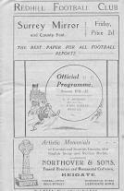
86 years ago today goals from Leslie Graves and Harry Payton were enough to defeat Redhill 2-1 at the Memorial Ground to reach the First Round Proper of the Amateur Cup for only the second time in our history. In the next round we would be drawn at Portman Road against Ipswich Town! (see programme left)

81 years ago today a Jimmy Jones penalty was not enough as we lost 2-1 after extra time in the Surrey Senior Cup to Banstead Mental Hospital. We had beaten them 6-0 earlier in the season so this was a surprise, but they would go on to reach the Semi-Final of the competition in the end. The most disappointing aspect of this defeat was that we would have been paired with our tenants Ewell and Stoneleigh in the next round. We never met competitively during their two year existence and apart from a couple of pre-season joint trial matches this was as close as we would ever get.

80 years ago this week we hammered Guildford City Reserves 8-1 in the London League with young striker Gordon Brogdale scoring a hat trick. Brian Beglan scored two goals but within a year he would be an important part of the Dulwich Hamlet team playing in the Isthmian League, while Brogdale would go on to play briefly for Crystal Palace in future years before returning to us after the War.

52 years ago today we suffered the greatest ever collapse in our history as we led Horsham 4-1 at half time and even extended the lead to 5-1 with Bill MacKay scoring a hat trick and a young Johnny Eales scoring his first goal for our club. However, somehow we contrived to lose this match 6-5!!

50 years ago this week we smashed eight goals past Eastbourne in a League match at West Street. Johnny Eales scored four goals for us while another was scored by a young Chris Kelly. It was the first time we’d scored eight goals since 1956 and we wouldn’t score this many again until 1974!

37 years ago today we brought a league match with Lewes forward to a Friday night as we marked the opening of our new Clubhouse with a 2-0 win. The official opening was carried out by the Mayor.

22 years ago today Steve Smith scored his only hat trick for the club as we defeated Carshalton F.C. 3-0 in a Surrey Senior Cup tie. This club were in the Southern Amateur League and have no connection to Carshalton Athletic apart from sharing the same town!

Combined Counties League Premier Division
Opponents All-time Records
inc Saturday  18th November | P | W | D | L | F | A | PPG | GD | Best  Win | Worst  Loss
Godalming Town** | 1 | 1 | 0 | 0 | 2 | 1 | 3.00 | +1 | 2-1 | X
Abbey Rangers | 4 | 3 | 0 | 1 | 11 | 4 | 2.25 | +7 | 7-1 | 2-3
Sutton Common Rovers | 13 | 9 | 2 | 2 | 30 | 19 | 2.23 | +11 | 4-0 | 0-5
Horley Town | 31 | 21 | 5 | 5 | 69 | 34 | 2.19 | +35 | 6-0 | 1-3
Spelthorne Sports* | 8 | 5 | 2 | 1 | 16 | 11 | 2.13 | +5 | 6-2 | 1-5
Banstead Athletic | 38 | 23 | 7 | 8 | 62 | 38 | 2.00 | +24 | 5-0 | 0-4
Bedfont Sports | 12 | 7 | 2 | 3 | 21 | 19 | 1.92 | +2 | 5-1 | 0-7
Guildford City | 18 | 11 | 1 | 6 | 35 | 22 | 1.89 | +13 | 5-1 | 1-5
Westfield | 21 | 12 | 3 | 6 | 43 | 36 | 1.86 | +7 | 6-1 | 0-4
Colliers Wood United | 24 | 14 | 2 | 8 | 47 | 39 | 1.83 | +8 | 4-0 | 0-5
Farnham Town | 17 | 9 | 4 | 4 | 30 | 25 | 1.82 | +5 | 3-0 | 1-4
Knaphill | 9 | 5 | 1 | 3 | 19 | 15 | 1.78 | +4 | 4-0 | 2-6
Walton & Hersham | 52 | 25 | 11 | 16 | 105 | 99 | 1.65 | +6 | 8-0 | 1-9
Hanworth Villa | 18 | 8 | 5 | 5 | 39 | 28 | 1.61 | +11 | 5-0 | 1-4
Camberley Town* | 91 | 38 | 23 | 29 | 159 | 126 | 1.52 | +33 | 9-1 | 0-4
Redhill | 34 | 14 | 2 | 18 | 63 | 74 | 1.29 | -11 | 7-2 | 2-8
Chertsey Town | 51 | 19 | 5 | 27 | 77 | 95 | 1.22 | -18 | 3-0 | 0-7
North Greenford United | 13 | 4 | 2 | 7 | 19 | 24 | 1.08 | -5 | 3-0 | 1-4
AFC Hayes | 11 | 2 | 3 | 6 | 18 | 20 | 0.82 | 0 | 7-0 | 0-3
CB Hounslow United | 4 | 1 | 0 | 3 | 6 | 11 | 0.75 | -5 | 2-0 | 1-5
Balham | - | - | - | - | - | - | - | - | - | -
* includes one abandoned match v Camberley and one loss on penalties v Spelthorne
** Godalming Town known as Godalming & Guildford when we played them

EL Records Premier Challenge Cup
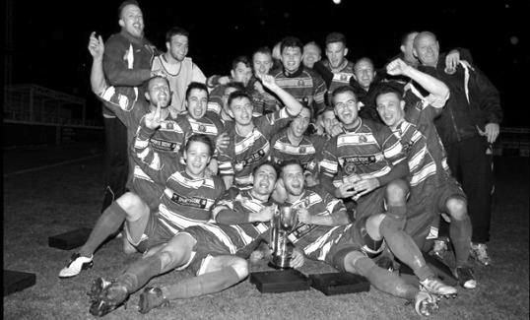
First Round
Camberley Town | 0-3 | Redhill
CB Hounslow United | 5-2 | Eversley & California
South Park Reserves | 3-4 | Horley Town
Staines Lammas | 2-2+ | Chertsey Town
Chertsey Town won 5-4 on penalties
Raynes Park Vale | 3-2 | Hanworth Villa
FC Deportivo Galicia | 1-0 | AC London
Sutton Common Rovers | 3-1 | Westfield
Worcester Park | 4-2 | Epsom & Ewell
Second Round
CB Hounslow United | 1-2+ | Worcester Park
Chertsey Town | 1-0 | Horley Town
Colliers Wood United | 4-1 | Balham
AFC Hayes | 0-1 | Cobham
Knaphill | 3-1 | Guildford City
Cove | 0-1 | Sutton Common Rovers
Bagshot | 1-4 | North Greenford United
Bedfont Sports | 6-1 | Farleigh Rovers
Redhill | 9-0 | Fleet Spurs
Kensington Borough | 4-3 | Raynes Park Vale
Bedfont & Feltham | 0-1 | Godalming Town
Chessington & Hook United | 5-2 | Sheerwater
Spelthorne Sports | 5-1 | Ash United
Walton & Hersham | 6-1 | Badshot Lea
Abbey Rangers | 1-3 | FC Deportivo Galicia
Banstead Athletic | 0-3 | Farnham Town
Third Round
Cobham | 5/12 | Farnham Town
North Greenford United | 0-4 | Colliers Wood United
Sutton Common Rovers | 4/12 | Redhill
Godalming Town | 5/12 | Chessington & Hook United
Knaphill | 21/11 | Kensington Borough
Bedfont Sports | 0-1 | Walton & Hersham
Spelthorne Sports | 28/11 | Chertsey Town
Worcester Park | 9/12 | FC Deportivo Galicia

Centre page for results

Centre page for results

Godalming Town – History
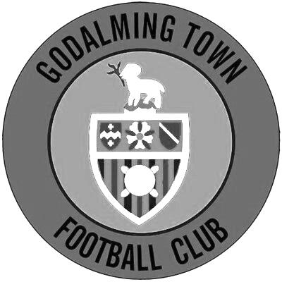
The club has its origins as Godalming United FC, formed in 1950 by ex-pupils of Godalming Grammar School. Between 1950-71 the club played at the Recreation Ground. However, in 1970 Surrey Senior League side Farncombe collapsed, leaving their ground in Meadrow vacant. Godalming took over the debts and tenancy, changing their name to Godalming and Farncombe FC, and the ground to Wey Court in the process.

The original pitch was where the nearby Wey Court Sheltered Housing stood and considerable amount of work was undertaken on the new playing area, which was built on the site of an old waste tip. The club was helped by Waverley Council when drainage problems and subsidence meant they had to find a temporary home at Broadwater Park.

The club was accepted into the Combined Counties League for the start of the 1978 season, and a year later the name was changed again, to Godalming Town FC.

In 1985, another local club, Addlestone & Weybridge, was disbanded and, before their ground at Liberty Lane was demolished, Godalming purchased the stand and perimeter fence for £225 and £50 respectively. The stand was re-erected at Wey Court, with seating and fascia added.

The next development came in 1992 when the Guildford Football Appeal (formed in an attempt to return the towns name to senior football, following the collapse of Guildford City in 1977) donated a sum of money towards floodlights, and in return the name of the club was changed again to Godalming & Guildford FC.

Further recycling followed in 1995, when a new turnstile building was erected incorporating a turnstile from Millwall’s old ground and in 1996 the clubhouse was refurbished.

During 2005 close season, the club changed its name for a fifth time, albeit back to one of its previous incarnations, that of Godalming Town. A fantastic 2005/06 season saw the side take the Combined Counties League Championship and League Cup by storm. Godalming Town were then accepted by Isthmian League officials following extensive ground improvements.

At the end of a tough season, Godalming found themselves at the bottom of a very competitive division. However, events elsewhere meant that Godalming were reprieved from relegation and were transferred into the Southern League’s South & West Division for the 2007/08 season. Chuck Martini replaced Roger Steer as Manager in October 2007. Town were moved back to the Ryman League for the 2008/09 season and eventually finished in another record high position, 9th. Godalming also progressed further than ever before in the FA Cup by reaching the 3rd Qualifying Round before

losing 2-1 at Conference South side Havant & Waterlooville who had earlier that year gone out of the previous year’s competition at Liverpool!

The 2009/10 season was arguably the best season in the history of the club. Town finished a record high position 4th in the Ryman South but were eventually beaten 2-1 in the Playoff Final at Folkestone Invicta. The club progressed further than ever before in the FA Trophy and won the Surrey Senior Cup by beating Sutton United 2-1. The season also saw local boy Shaun Elliott became the club’s record appearance holder after reaching 360 games in a Godalming shirt. Chuck Martini was replaced by joint-managers Jon Underwood & Neil Baker in October 2010 and the club finished an unpredictable season in mid-table.

The 2011/12 season saw a lot of new faces join, but the team quickly gelled, reaching the 4th Qualifying Round of the FA Cup, beating Wimborne, Moneyfields, Worcester City & Bodmin before bowing out to Maidenhead United in front of 700 at Wey Court. The G’s finished 5th in the league, and travelled to Bognor Regis Town in the playoff semi-final, drawing 4-4 after extra time but Godalming lost 5-3 on penalties.

2012/13 saw Jon Underwood and Neil Baker guide Godalming to their highest ever finish in the pyramid, finishing in 3rd place. The G’s lost in the playoff semi-final for the second year running, this time losing 2-1 to Biggleswade at Wey Court. The season finished on a high however, as Godalming lifted the Surrey Senior Cup for the second time in four years, beating Sutton United 1-0 at Gander Green Lane, thanks to a last minute goal from Scott Harris.

The close season saw Godalming moved to a third different league in as many years, this time to the South & West Division. With divisional change came a managerial change; Jon Underwood and Neil Baker left Godalming to join Slough Town, taking the majority of the squad with them. Andy Hunt was appointed manager in June 2013, assisted by Neil Selby.

The 2013/14 season was probably one of the hardest the club has dealt with. Andy Hunt was given the task of putting together a squad that will compete in the league and secure step four football. At Christmas 2013 the clubhouse, kitchen and changing rooms were ruined by flood water. Godalming finished the season in 18th position. Godalming were then moved into another division again and will play in Southern League Central Division for the 2014/15 season.

Godalming finished in 10th position in the 2015/2016 and reached the Surrey Senior Cup Final for the 3rd time but lost 4-0 to Merstham.

In 2016/2017 the G’s transferred to the Ryman League Division One South but finished bottom of the table and was therefore relegated. G’s first team manager Dan Turkington stepped down from his role.

The club then appointed Simon Funnell as new first team manager. He would be assisted by Matt Drew. Godalming Town will compete in the Combined Counties League Premier Division for the 2017/18 season.

CCL Premier Division Club Directory
ABBEY RANGERS Telephone: 01932-422962 - Colours: Black & White Stripes/Black/Black
Ground: Addlestone Moor, Addlestone. KT15 2QH

A.F.C. HAYES Telephone: 0208-845-0110 - Colours: Blue and White Stripes/Blue/Blue
Ground: Farm Park, Kingshill Avenue, Hayes. UB4 8DD

BALHAM Telephone: 0208-942 8062 - Colours: White & Black/Black/Black

Ground: Colliers Wood United FC - Wibbandune, Robin Hood Way, Wimbledon. SW20 0AA

BANSTEAD ATHLETIC Telephone: 01737-350982 - Colours: Amber &Black/Black/Black
Ground: Banstead Athletic, Merland Rise, Tadworth. KT20 5JG

BEDFONT SPORTS Telephone: 0208-831-9067 - Colours: Red & Black Hoops/Black/Red & Black
Ground: Bedfont Sports Club, Hatton Road, Bedfont. TW14 8JA

CAMBERLEY TOWN Telephone: 01276-65392 Colours: Red & White Stripes/Blue/Red
Ground: Krooner Park, Wilton Road, Camberley. GU15 2QW

CB HOUNSLOW UNITED Telephone: 0208-577 -9712 Colours: Green/Black/Green
Ground: CB Hounslow Sports Ground, Green Lane, Hounslow TW4 6DH

CHERTSEY TOWN Telephone: 01932-561774 - Colours: Royal Blue & White Stripes/ Blue/ Blue
Ground: Alwyns Lane, Chertsey. KT16 9DW

COLLIERS WOOD UNITED Telephone: 0208-942 8062 - Colours: Royal Blue/Black/Black
Ground: Wibbandune, Robin Hood Way, Wimbledon. SW20 0AA

EPSOM & EWELL Telephone: 01737-553250 - Colours: Royal Blue & White Hoops/Royal Blue/Royal Blue - Ground: Chipstead FC, High Road, Chipstead. CR5 3SF

FARNHAM TOWN Telephone: 01252-715305 - Colours: - Claret & Sky Blue /White/ Claret & Blue
Ground: Memorial Ground, Babbs Mead, West Street, Farnham. GU9 7DY

GODALMING TOWN Telephone: 01483-417520 - Colours: Yellow/Green/Yellow
Ground: Wey Court, Meadrow, Godalming. GU7 3JE

GUILDFORD CITY Telephone: 01483-443322 - Colours: Red & White Stripes/Black/Black
Ground: The Spectrum, Parkway, Guildford, Surrey. GU1 1UP

HANWORTH VILLA Telephone: 0208-831-9391 - Colours: Red & White Stripes/Black/Black
Ground: Rectory Meadows, Park Road, off Hounslow Road, Hanworth. TW13 6PN

HORLEY TOWN Telephone: 01293-822000 - Colours: Claret & Sky Blue/Claret/Claret
Ground: The New Defence, Anderson Way, Court Lodge Road, Horley. RH6 8SP

KNAPHILL Telephone: 01483-475150 - Colours: Red/Black/Red & Black
Ground: Brookwood Country Park, Redding Way, Lower Guildford Road, Knaphill. GU21 2AY

NORTH GREENFORD UNITED Telephone: 0208 422 8923 - Colours: Royal Blue & White/Royal Blue/Royal Blue - Ground: Berkeley Fields, Berkeley Avenue, Greenford, Middx UB6 0NX

REDHILL Telephone: 01737-762129 - Colours: Red and White Stripes/Red/Red
Ground: Kiln Brow, Three Arch Road, Redhill. RH1 5AG

SPELTHORNE SPORTS Telephone: 01932-961055 - Colours: Navy & Sky Blue/ Blue/ Blue
Ground: Spelthorne Sports Club, 296 Staines Road, Ashford Common, Ashford. TW15 1RY

SUTTON COMMON ROVERS Telephone: 0208-644-4440 - Colours: Yellow/ Yellow / Yellow
Ground: Sutton United FC, Gander Green Lane, Sutton. SM1 2EY

WALTON & HERSHAM Telephone: 01932-245263 - Colours: Red & White Trim/Red/Red
Ground: Stompond Lane, Walton on Thames. KT12 1HF

WESTFIELD Telephone: 01483-771106 - Colours: Yellow/Black/Black
Ground: Woking Park, Kingfield Road, Woking. GU22 9BA

Match and Ball Sponsorships – 2017/18
Opponent | Date | Match Sponsor | Ball Sponsor
Banstead Athletic (FAC) | 06/08/17 | Club President - Stella Lamont
Chertsey Town | 15/08/17 | EEFC Management Committee
Redhill | 02/09/17 | Building Shop Ltd
Spelthorne Sports | 09/09/17 | In memory of Betty Dyke
Horley Town | 12/09/17 | Alex McKay (Senior)
Hanworth Villa | 23/09/17 | Jack Jarman
North Greenford United | 28/10/17 | Marvin and Kathy Hough
Farnham Town | 14/11/17 | In memory of Dave and Lizzie Marshall
Godalming Town | 21/11/17 | Building Shop Ltd
Guildford City | 02/12/17 | John Bonner
Abbey Rangers | 16/12/17
Walton & Hersham | 30/12/17
Balham | 20/01/18
Sutton Common Rovers | 03/02/18
CB Hounslow United | 13/02/18
Knaphill | 24/02/18
Camberley Town | 10/03/18
Bedfont Sports | 24/03/18
Colliers Wood United | 30/03/18
Banstead Athletic | 02/04/18 | Nathan Lambert – 10 years old today!
Westfield | 14/04/18
AFC Hayes | 28/04/18 | Club President - Stella Lamont
Match sponsorship costs just £60.00.

Sponsorship includes:

Admission, programmes and hospitality for three people.

A full page advert in the programme and mascot for the day (if required).

Also, you get to choose the player of the match, who will receive a prize

If you are interested, just speak to a Committee Member,
or drop me an email at: richard.c.lambert@gmail.com

Every Opponent A-Z
Over the years we have played many, many different opponents. Exactly how many is a difficult question, as it all depends on your definition. Are Camberley & Yorktown different to Camberley Town, or are Epsom Town different to Epsom F.C. or Epsom & Ewell F.C.?

In my analysis I have classed them as the same team, and will work through them all from A to Z. Some we have played many times, whilst others we have met maybe just once or twice. Enjoy!

Whyteleafe Albion: Played 6 - W5 D0 L1 - F19 A8 - PPG - 2.50 - Fantastic

New Barn Lane was the original home of the first senior status club in Whyteleafe. They rose quickly into the London League, where we first met them in the 1929/30 season, and a more bizarre set of results you couldn’t have found that year!

On 14th December 1929 we visited Old Barn Lane and won fairly convincingly by six goals to nil with E.G. Matkin scoring four of them. However, just five weeks later on 18th January 1930, they returned the compliment at West Street by six goals to one!

We met four times in 1930/31 with Matkin again scoring four in a 5-0 win in the Surrey Charity Shield but this time we would go on to win the other matches, in the League by 3-0 at home and 2-1 away and most importantly by two goals to one on 22nd November 1930 in the Final Qualifying Round of the Amateur Cup, which earned us our very first visit to the First Round Proper which was the last 64 in those days. We then gave the cup holders Ilford a huge fright leading 2-0 in the second half before going out 5-2.

Whilst not setting the league alight in either season; finishing thirteenth and then eleventh in a fourteen team league, they resigned at the end of 1930/31 and we never met again. However, the stand remains in existence within the grounds of Kenley Primary School and can still be seen from Valley Road. Or on Google Maps!

Whyteleafe: Played 23 - W9 D5 L9 - F45 A39 - PPG - 1.39 - Average

The new club we know today was formed in 1946, still playing at New Barn Lane but when they wanted to move up to the Surrey Senior League they found that they needed a better venue to be accepted, so they moved to Church Road where they reside today and joined the Surrey Senior League in August 1958.

We first met the new club in a Surrey Senior Cup tie on 23rd September 1961, edging them out 3-2 but by the time of our next meeting in October 1972 we were in what would prove to be our final Athenian League season before being jettisoned and we lost 1-0 after extra time to a Whyteleafe team including our recent kit sponsor Malcolm Shelbourne, who had played for our Reserves a season or two previously.

We met in Surrey Senior League action as equals in 1973/74, winning 5-1 at West Street with three goals from Tommy Tuite and a pair from Dave Ritman but lost the return 2-0 as we finished runners-up behind Westfield. In 1974/75 a Phil Walker goal was enough to progress in the Surrey Senior League Charity Cup in February 1975 but our two league matches were more memorable, especially the first on Monday 21st April 1975. This came just two days after our Wembley Stadium F.A.Vase Final defeat to Hoddesdon Town but our players still had plenty of energy and destroyed Whyteleafe at Church Road by nine goals to nil; a result that is still a club record win away from home, although of course we finally matched the nine goals away from home at Bedfont &

Feltham in August of 2016. The return match was our final game of the season and we won 3-1 with goals from Trevor Lee (2) and Tommy Tuite and received the trophy that day.

As we went onwards and upwards for a while we occupied different levels, although we did meet in the Surrey Senior Cup on 29th January 1985, winning 2-1 with all three goals coming in the first seven minutes and a brief floodlight failure was the only other memory of note as I recall! But in 1987/88 two relegations placed us into Isthmian Division Two South and we met four times over the next two seasons, drawing three and narrowly losing one of the matches. In 1988/89 we led in both matches but were pinned back; the first after a 40 yard strike from Marc Flemington at Whyteleafe and in the return Brian Perkins put us ahead in the 89th minute but we still drew 1-1!

By now they were a very good side and reached the First Round of the F.A. Cup with players like our former star Steve Milton in the line-up who would shortly move on to Fulham. However, we knocked them out of the County Cup in 1989 and 1990, although we lost in 1991 by the only goal.

And that was it for quite a while until we were paired in the County Cup once again in 2001/02, where despite being two Leagues below then at the time we produced a superb 3-1 win on 22nd January 2002. Of course that season due to reorganisation we would earn a double promotion and suddenly we were back in the same division!

In 2002/03 we conceded in the first half and then again in the 90th minute, but incredibly scored twice in injury time to pinch a 2-2 draw! However, we lost the return match at Merland Rise 3-1 and in our relegation season of 2003/04 we led 2-1 before Simon Hatton was needlessly sent off, leading to a 2-5 defeat and then conceded a very late goal at home to lose 0-1. It must be remembered that we went down by a point that season.

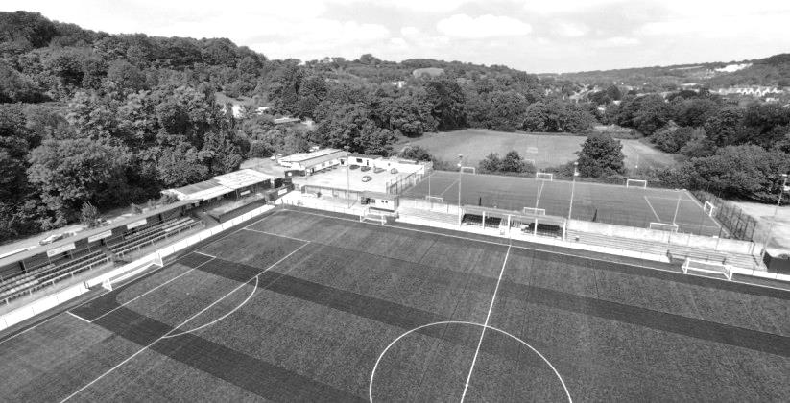
So down we went again and didn’t meet for nine years until Whyteleafe were a Step Five club themselves. Then we were drawn together in both F.A. Cup and F.A. Vase! We worked hard to recover a 3-1 half time deficit at Church Road in the Cup to earn a replay with a 3-3 draw, only to be hammered 6-1 at High Road with future player Taylor Smith scoring a hat trick in fifteen minutes. They had a very good team this year and were destined to return to the Isthmian League but we still led them for an hour in the Vase before conceding towards the end and losing 2-3 in extra time at Chipstead.

Since then they have established themselves once again in the Isthmian League and remain at Step Four, with the only other notable change being the addition of an artificial surface at Church Road.

Church Road, with the large nineties stand behind the goal on what used to be a grassy bank!

Player Sponsorship
Here is the latest list for 2017/18, with new photos showing all of our players and Management that are available for sponsorship. Other new players will be added shortly.

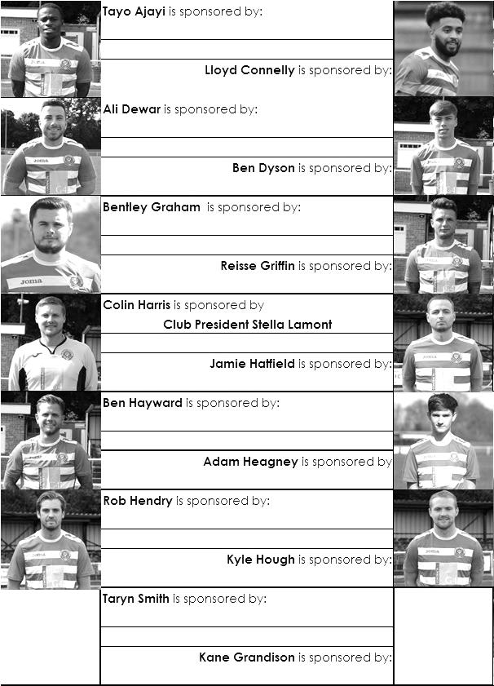

Sponsorship costs just £40 and it is easy to do. Just select a player who has not been previously sponsored and let a Committee Member know that you would like to sponsor them. Beware though. Until we have received the money it is possible for someone to jump in front of you, so don’t delay, sponsor today!

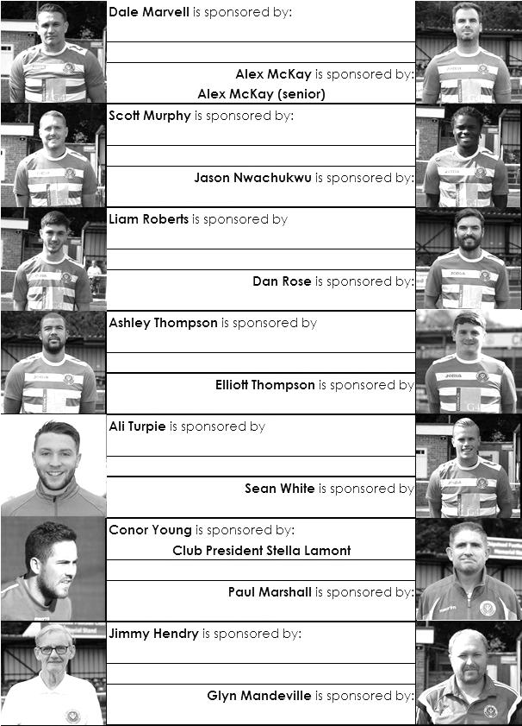

Salts Super Six Predictor
The Salts Super Six Predictor is up and running again with a jackpot of £147 and the tickets are on sale at today’s game to the left of the gate. The matches are to be played this Saturday.

The competition is easy to play! To win, you simply need to predict the results of six matches correctly from the three options, fill in the form and make sure it is back with our seller before the deadline on the ticket. The latest fixtures are shown below.

If you are a club regular, you just need to place your name on the sheet, although if you aren’t, then we’ll need a contact number from you too. We will announce any winners on the website within three working days, so don’t worry, we won’t miss you!

Please note that if there is more than one winner, the prize pot would be shared between the winners. All you need to do now is have a go, as many times as you like!

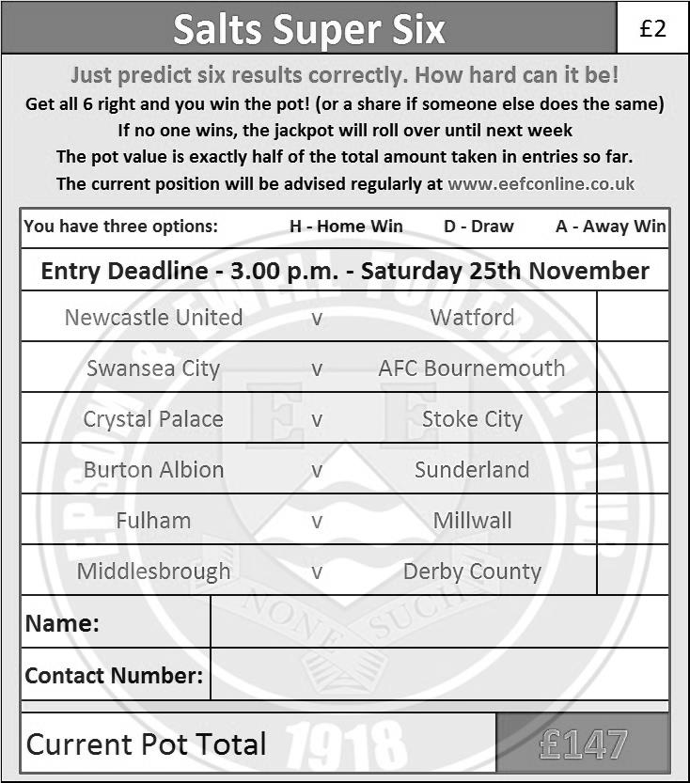

Good luck!

Merchandise
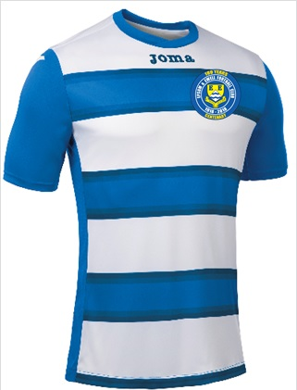
To celebrate our Centenary season we are shortly to have a new kit which will also contain our brand new Centenary badge. We will also be selling polo shirts in either Royal Blue or White.

The costs are being finalised now but if you would like to purchase either a replica new shirt or polo shirts, then let us know and we will get them to you for Christmas or maybe just afterwards. You know where we are!

Be part of the Salts Centenary!

#Saltsfamily

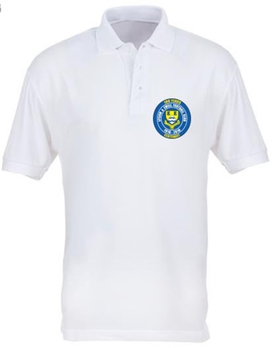
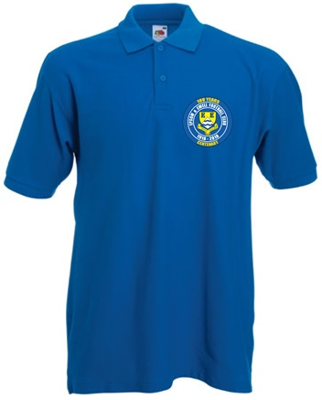

Combined Counties League – Premier Division
Tuesday, 21st November 2017 - Kick-off 7.45 p.m.
Epsom and Ewell  (Royal Blue & White hoops) | V |  | Godalming Town  (Green / Yellow)
Squad | NUMBERS |  | Squad
Conor Young |  |  | Dimitrios Kyriatkis
Reisse Griffin |  |  | Scott Elgar
Sean White |  |  | Joshua Kempton
Dale Marvell |  |  | Isy Nzelo
Ben Dyson |  |  | Steve Betancourt
© Alex McKay |  |  | Piers Oldland
Liam Roberts |  |  | Jon Bennett
Kane Grandison |  |  | Ben Cotton
Taryn Smith |  |  | Bobby Bennett
Lloyd Connelly |  |  | Robert Webbe
Adam Heagney |  |  | Hakim Griffiths
Ashley Thompson |  |  | Esteban Selgado
Daniel Rose |  |  | Tre Trowers
Endrit Dobraj |  |  | Calum Roots
Kyle Hough |  |  | Mert Varli
Jason Nwachukwu |  |  | Tom Webb
Ben Franklin
Scott Murphy
Rob Hendry
Calum Kennedy
Jamie Hatfield
Joe Jasper
Ali Dewar
Ben Hayward
Glyn Mandeville | MANAGER |  | Gavin Smith
Alex McKay | ASSISTANT |  | Jon Palmer
Neil Grant / Jimmy Hendry | COACHES / PHYSIO |  | Paul Barry / Liam O’Connor
REFEREE: G.Mays
ASSISTANTS: D.Vernon, R.Wells
Today’s Match and Match Ball are kindly sponsored by:
The Building Shop Ltd

OUR NEXT VISITORS TO HIGH ROAD
Guildford City
Cherry Red Combined Counties League – Premier Division
Saturday 2nd December 2017 – 3.00 p.m.

